Setting up your new masd.k12.ms.us email account
- Access any internet browser and go to gmail.com (sign out of your current account if you are logged in)
- Log in with your new masd.k12.ms.us email address
  - In most cases your address will be the first initial of your first name plus your last name @masd.k12.ms.us (jdoe@masd.k12.ms.us)
  - Password1 was used as the initial password. Accept the terms and any other Google pop up.
- After you log in for the first time, change your password!
  - Click the Google Account icon in the top right of the screen, click Google Account in blue, click Personal Info on the left, then click Password. You will have to enter Password1 again to verify it’s really you before you can add a new password. Your new password will have to be at least 12 characters long. 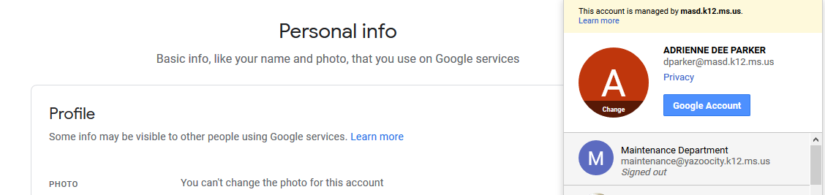
- Next you will merge your current district email account into your new masd.k12.ms.us account. You can eliminate these steps if you do not have messages you wish to pull from your current email account
  - Open another browser and log into your current district email account (jdoe@yazoocity.k12.ms.us or jdoe@humphreys.k12.ms.us)
  - Click the Gear icon in the top right of the screen, then click Settings
  - Click Forwarding and POP/IMAP
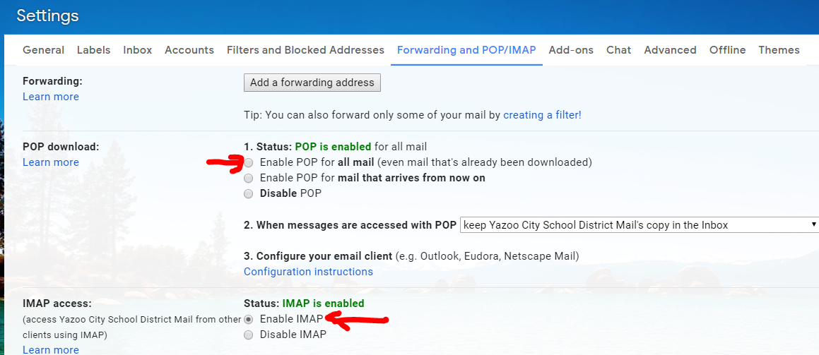
  - Click Enable POP for All Mail
  - Click Enable IMAP
  - Click SAVE and close the browser
  - Go back to or log into your masd.k12.ms.us account again
  - In the masd.k12.ms.us account, click the Gear icon in the top right of the screen, then click Settings
  - Click Accounts, then click Add Account under the Check mail from other accounts section
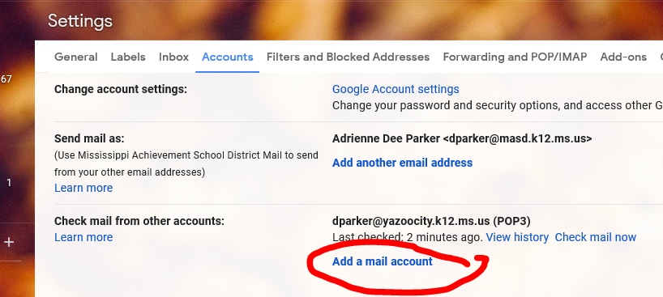
  - Enter your current district email account ((jdoe@yazoocity.k12.ms.us or jdoe@humphreys.k12.ms.us)
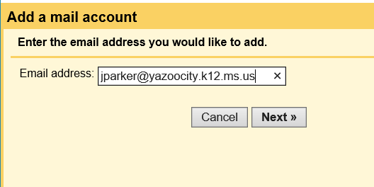
  - In the next box, enter your Yazoo City/Humphreys district email address in the Username field
  - Enter your Yazoo City/Humphreys district email password in the Password field
  - Enter pop.gmail.com in the POP Server field
  - Select 995 in the Port field
  - Check Always use a secure connection (SSL)
  - Click Add Account
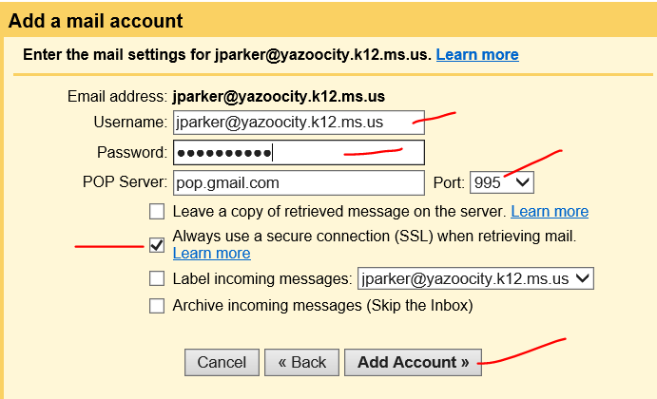
  - The next screen should say that you have successfully added your mail account and ask if you want to send mail from your Yazoo City/Humphreys account. Answer no to this question and click Next to take you back to the Settings screen.
  - While still in the settings, click Forwarding and POP/IMAP, click Enable POP for All Mail, click Enable IMAP, and click SAVE
  - Old and new messages from both of your email accounts will now come to your new masd.k12.ms.us inbox

