Setting up Groups with Google

- While in your gmail account, click the nine dots (Google Apps) in the upper right-hand corner
- Click Groups
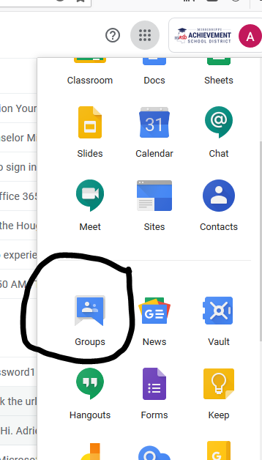

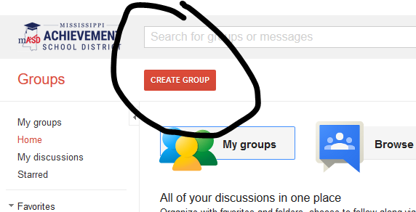
- Click Create Group

- Create a Group Name
- Assign the email address to your group (no spaces or capital letters in the email address)
- Note the new email address. You will use this address to email your group members

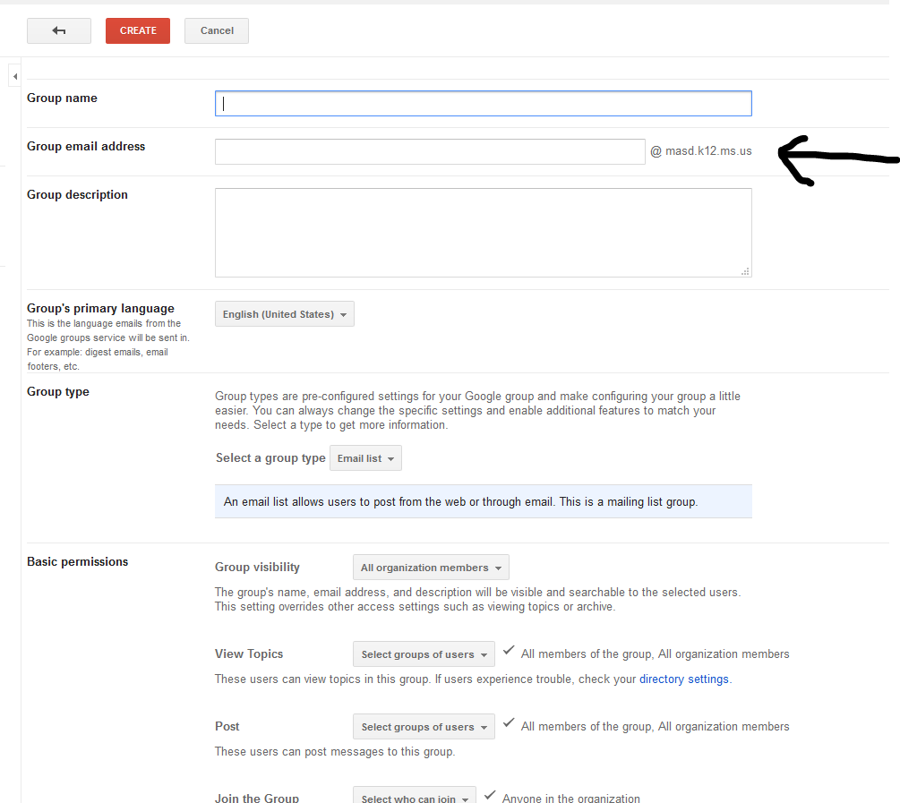

- After you group has been created, click on My Groups, then Manage Members

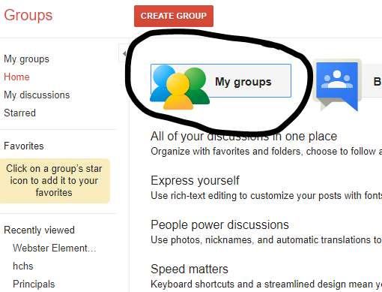
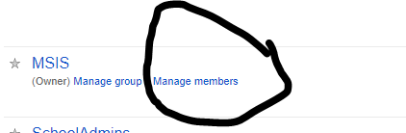

- On the left of the screen, click Direct add members
- Enter the email addresses of the members you wish to add. Separate each email address with a comma.

